UNDER EMBARGO UNTIL 00:01, THURSDAY 4TH JUNE 2026
iFi Unveils the New iDSD GR 2: A Legend, Perfected
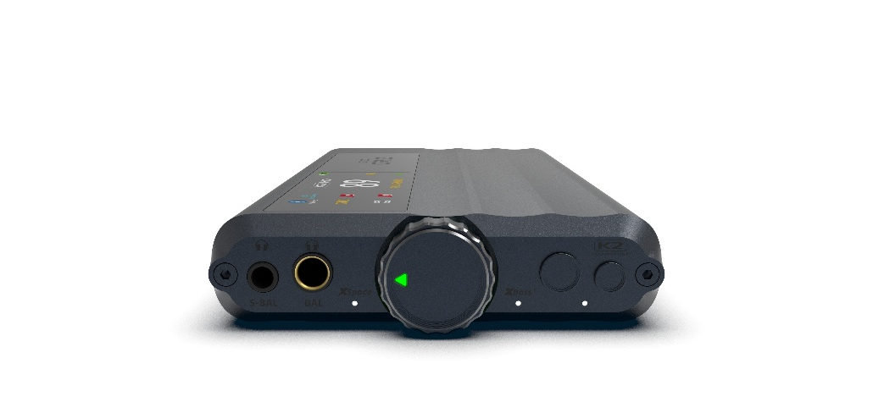
Southport, UK: iFi audio, a trailblazer in audio innovation, announces the launch of the new iDSD GR 2, the next evolution of one of the company’s most celebrated portable audio products.
Continuing the legend of the xDSD Gryphon, the iDSD GR 2 carries forward its mythos: a portable powerhouse designed for audiophiles who wants uncompromising sound beyond the confines of the desktop.
Rebuilt from the ground up, it reimagines the Gryphon for a new era, introducing an all-new DAC architecture, upgraded fully balanced amplification, an intuitive OLED touchscreen interface, JVCKENWOOD’s K2HD Technology, and lossless Bluetooth connectivity. The result is a legend, perfected - iFi audio’s most versatile true-portable DAC/Amp to date.

Key Features of the iDSD GR 2 include:
- New PCM1795 DAC with bespoke balanced circuit design
- Colour OLED touchscreen interface with capacitive control
- Up to 1,513mW RMS into 32 ohms - 50% more power than its predecessor
- K2HD Technology restores harmonic richness and musicality
- Bluetooth 5.4 with aptX Lossless and LDAC support
- Hybrid power mode designed to extend battery lifespan
- Versatile connectivity with BT, USB, S/PDIF, and line options
- XSpace and XBass+ analogue processing modes
- iFi Nexis app support for OTA updates and additional control
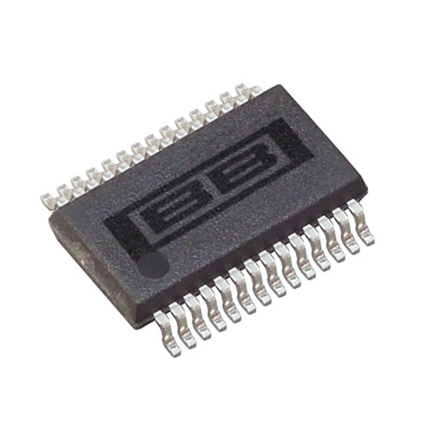
PCM1795. Pure Conversion Magic.
At the heart of the GR 2 is a major step forward in conversion architecture, marking the first use of the Burr-Brown PCM1795 DAC chipset within an iFi audio product. It preserves the warm, analogue character synonymous with iFi, while delivering true 32-bit resolution, lower distortion, and greater dynamic range.
As a current-output DAC, the PCM1795 also unlocks greater design freedom, enabling iFi to design fully bespoke I/V and output stages, optimised to extract its full performance potential. Class A op-amps offer a more natural analogue character, while a refined circuit topology – now fully balanced from preamp to headphone stage with unnecessary electronic switching removed – has considerably reduced distortion across the signal path.
It is a sophisticated design, but the payoff is simple – lower distortion, greater transparency, and more authentic connection to the music.

Control, Evolved.
A new capacitive touchscreen OLED display brings direct, intuitive control to the surface of the GR 2.
Core settings are now immediately accessible, removing the need for deep menu navigation. Designed with speed and clarity in mind, the interface makes adjustments feel immediate, natural, and highly responsive – placing control directly at the user’s fingertips.

xDSD Gryphon: 1,000mW RMS @ 32ohms
iDSD GR 2: 1,513mW RMS @ 32 ohms

Headroom Unlocked.
Alongside physical control via the new interface, iFi also unlocks greater control over what you hear.
The iDSD GR 2 delivers up to 1,513mW RMS into 32 ohms - 50% more headphone drive than the original Gryphon - providing substantial headroom for more demanding loads.
The result is effortless control under pressure: bass stays composed, transients remain sharply defined, and dynamics open more freely, even with harder-to-drive headphones.



Restoring Musicality.
Digital recordings can often lose the warmth and natural richness of the original performance, leaving music feeling flat or clinical.
The GR 2 is the latest iFi audio product to feature JVCKENWOOD’s K2HD Technology, a unique harmonic restoration algorithm that restores depth, tone, and musicality by reintroducing subtle detail, bringing recordings closer to their original intent.
The result is a more natural, engaging listening experience, where digital playback feels less processed and more emotionally connected to the performance. For those who prefer a lighter touch, ‘K2’ mode offers similar enhancement without upsampling.
The GR 2 also includes four selectable digital filtering options, allowing listeners to fine-tune the character and presentation of their music.

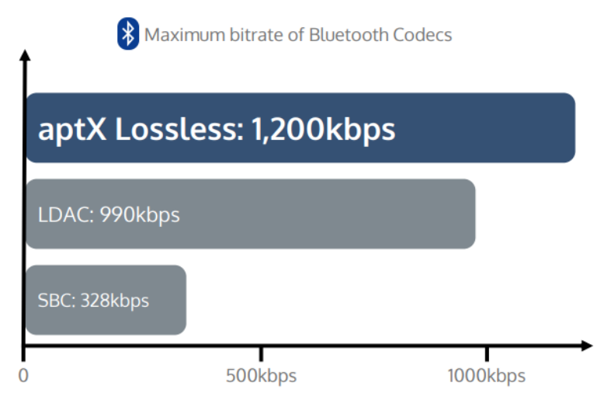

Freedom Without Loss.
GR 2 marks a new generation of portable audio, now paired with the latest advances in wireless connectivity through Bluetooth 5.4 and aptX Lossless.
Together, they deliver a wireless experience that preserves full detail at CD quality (44.1kHz, 16-bit), bringing listeners closer to the performance without the constraints of cables.
For those looking for the highest available bitrate short of fully lossless transmission, LDAC support enables premium-quality playback with bitrates up to 990kbps.

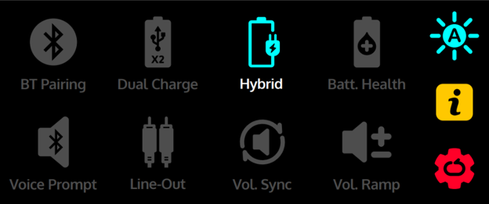

Power That Adapts.
The GR 2 introduces a new hybrid power mode that intelligently balances external power and battery operation.
When connected to an external supply, it prioritises mains power for day-to-day listening. Should extra power be required, GR 2 will draw from the internal battery before automatically returning to external power once demand subsides.
This approach reduces unnecessary battery cycling, making the GR 2 better suited to extended listening sessions while preserving long-term battery health.

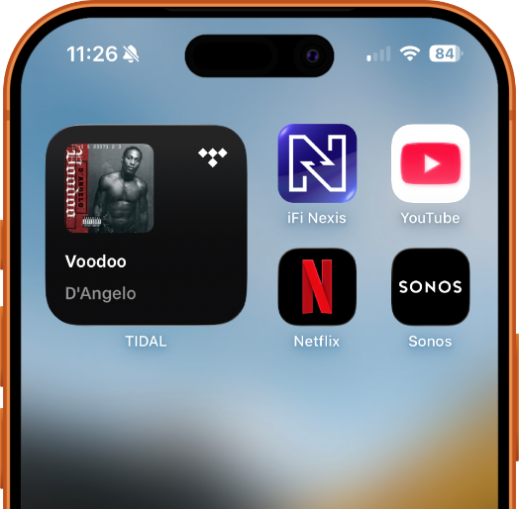

Control Beyond the Device.
The GR 2 is fully compatible with iFi Nexis, extending control beyond the device itself. Through the app, advanced settings can be accessed and fine-tuned with ease, offering deeper personalisation without complicating the everyday experience.
iFi Nexis also enables over-the-air updates, allowing the GR 2 to continue evolving over time with new features, refinements, and performance improvements long after it leaves the box.

Pricing & Availability
The iDSD GR 2 is available to purchase at ifi-audio.com and authorised dealers for £529/$529 USD/€549/$799 CAD.

UK Press Contact:
ifi@ranieri.agency


Established in 2012 and headquartered in Southport, UK, iFi audio is a globally recognised developer and manufacturer of high-fidelity audio solutions. Its product portfolio encompasses portable, desktop, and lifestyle devices designed to deliver exceptional sound performance through advanced engineering and innovative design. Guided by a ‘music first’ philosophy, iFi’s products have received numerous international awards and acclaim from professionals and enthusiasts alike, reinforcing its position as one of the leading brands in modern audio. www.ifi-audio.com

