UNDER EMBARGO UNTIL 19:00 BST, THURSDAY 1ST OCTOBER 2026
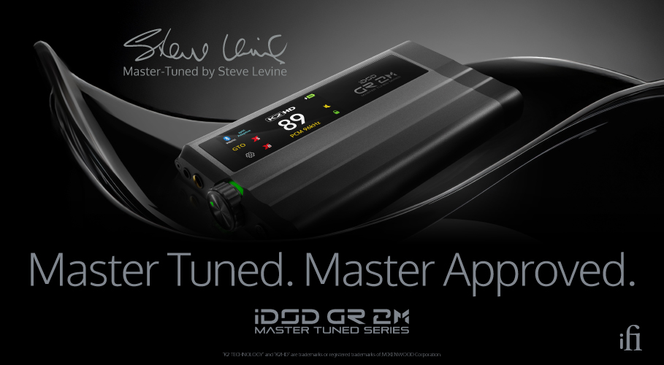
Master Tuned. Master Approved. iFi audio’s legendary GR2 gets studio upgrades
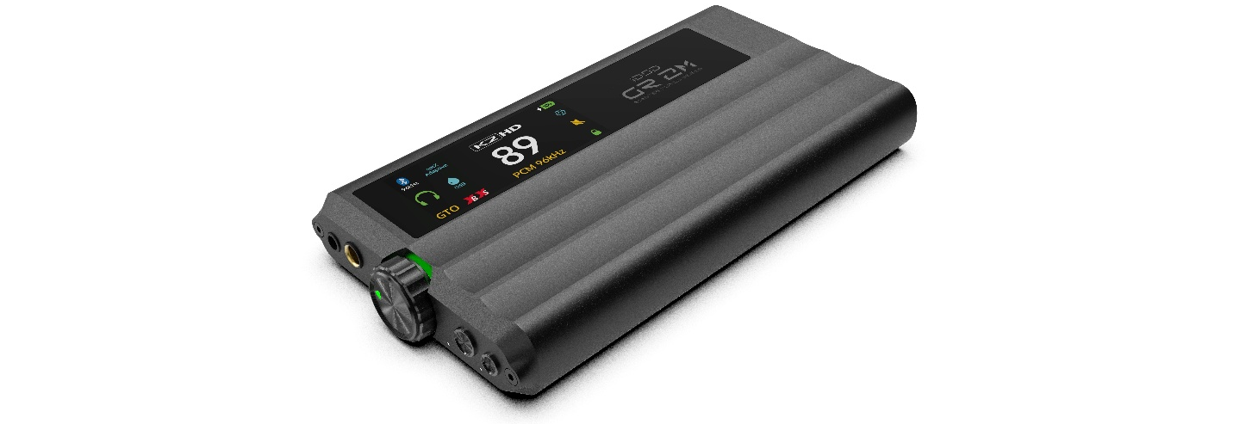
Master Tuned version of the iDSD GR2 reimagined through the ears of Grammy and Brit Award-winning producer Steve Levine

Southport, UK: iFi audio, a British pioneer in audio innovation, has announced the launch of the iDSD GR2 MT, a Master Tuned version of its acclaimed iDSD GR2 portable DAC/amp. Reimagined through the ears of Grammy and Brit Award-winning producer Steve Levine, the GR2 MT pairs

component-level upgrades with two exclusive, Levine-voiced digital filters to deliver the balance and emotional potency that defines his signature sound. Every sonic decision was guided by Levine himself, is the sound of a lifetime of studio experience and critical listening.
Steve Levine is a celebrated British record producer whose credits span genres and generations, from Culture Club and the Beach Boys to Gary Moore, Ziggy Marley, and Lemmy and Motorhead. His contribution to music has earned him a number of prestigious industry honours, including a Brit Award, a Musicweek Award, and a Grammy for his work with Deniece Williams. Today, Levine continues to produce exciting new talent from his studio in the heart of Liverpool's Baltic Triangle, including artists signed to his own label, Baltic Jazz Records.
“The goal of any producer is to document the authenticity and emotion behind the artist’s performance,” says Levine. “I have voiced the iDSD GR2 MT with this same goal in mind, and I hope you feel that when you listen”.

Key Upgrades
The GR2 MT builds on the standard GR2 with a series of component-level upgrades. Its high-resolution touch colour display now carries an illuminated silkscreen logo, while the standard FR-4 circuit board is replaced with an aerospace-grade hydrocarbon ceramic PCB offering near-zero signal loss.

The GR2’s OVA2637 with standard surface-mount resistors DAC I/V stage is replaced with OV4627A with audiophile-grade tantalum resistors, and the amp stage moves from standard electrolytic capacitors to Audio Note Kaisei capacitors.
As with its predecessor, at the core of the iDSD GR2 MT is the Burr-Brown PCM1795 DAC, fitted with Levine’s two exclusive filters, alongside JVCKENWOOD’s K2HD Technology, which recovers the depth and nuance of master recordings. The device delivers over 1,500mW RMS power output at 32 ohms, driven through an OLED display with capacitive touchscreen control.
Wireless listeners are served by Bluetooth 5.4 with aptX Lossless and LDAC, enabling CD-quality playback with no data loss, while a desktop mode allows the unit to bypass its internal battery for stationary use. Hybrid power modes are designed to maximise battery lifespan, connectivity spans both digital and analogue options, and the GR2 MT is fully compatible with the iFi Nexis app for over-the-air updates and advanced control.
Launch Event
iFi audio will be unveiling the iDSD GR2 MT for the first time at an exclusive jazz-themed listening event at World Heart Beat Studios, London on October 1st, 2026. Guests will be amongst the first to see the device up close and hear directly from Steve Levine on developing the product and its exclusive filters during an interactive Q&A. He will also be delivering a multitrack DAW session demonstrating the GR 2 MT in action, before allowing guests to get hands-on with listening stations themselves over drinks and canapés.
The evening also features insight from the owner of Stand Alone Productions, Gareth Johnson who will be discussing his experience with the GR2 MT.
For those unable to attend in person, the event will be livestreamed on the World Heart Beat website from 7pm BST, with viewers able to interact and submit questions during the Q&A session. An exact link to the livestream will be shared across iFi’s dedicated social media channels closer to the date.

Pricing & Availability
The iDSD GR 2 MT is available to purchase at ifi-audio.com and authorised dealers for £699/$699 USD/€729/CA$799.99

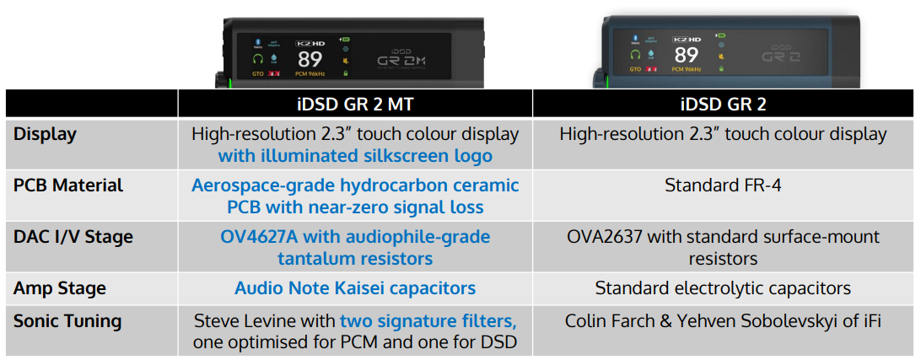

UK Press Contact: ifi@ranieri.agency



Established in 2012 and headquartered in Southport, UK, iFi audio is a globally recognised developer and manufacturer of high-fidelity audio solutions. Its product portfolio encompasses portable, desktop, and lifestyle devices designed to deliver exceptional sound performance through advanced engineering and innovative design. Guided by a ‘music first’ philosophy, iFi’s products have received numerous international awards and acclaim from professionals and enthusiasts alike, reinforcing its position as one of the leading brands in modern audio. www.ifi-audio.com

